Hyperbola as a Locus

Definition
# Source: AI Source: Provided by: [Data Path: Persons Table -> ID Column: 1, Name_En Column: Motasem Essam] -> From: [ChatGPT] on [7/25/2026]
A hyperbola is the locus of all points in a plane for which the absolute difference between the distances to two fixed points is constant.
The two fixed points are called the foci.
If:
- $F_{1},F_{2}$= fixed foci
- $P$= variable point
- $PF_{1},PF_{2}$= distances from $P$to the foci
- $2a$= fixed positive constant
then the defining condition is:
$$\boxed{∣PF_{1}-PF_{2}∣=2a}$$
Therefore:
$$\boxed{P\text{ lies on the hyperbola }⟺ ∣PF_{1}-PF_{2}∣=\text{constant}}$$
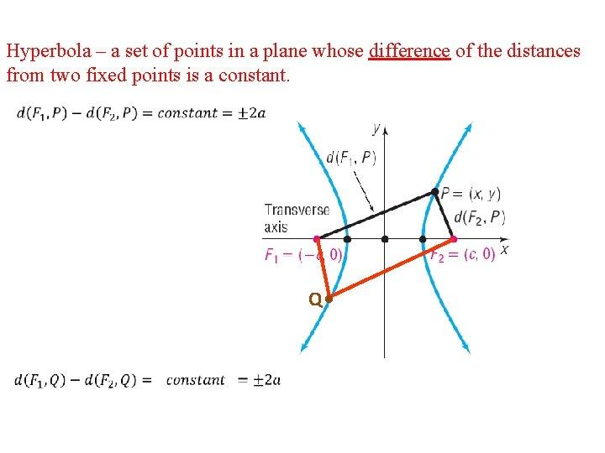
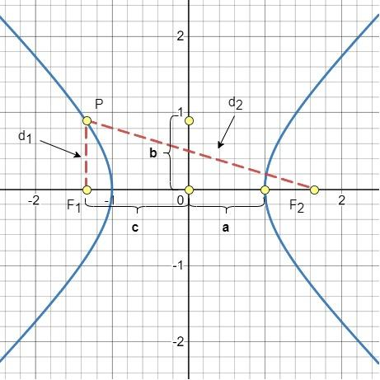
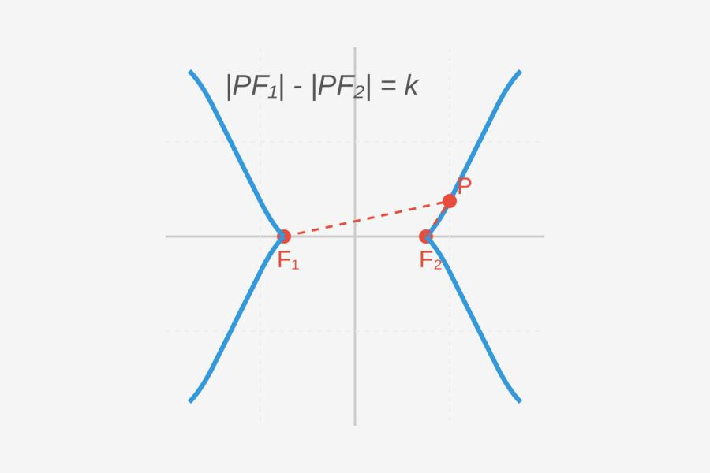
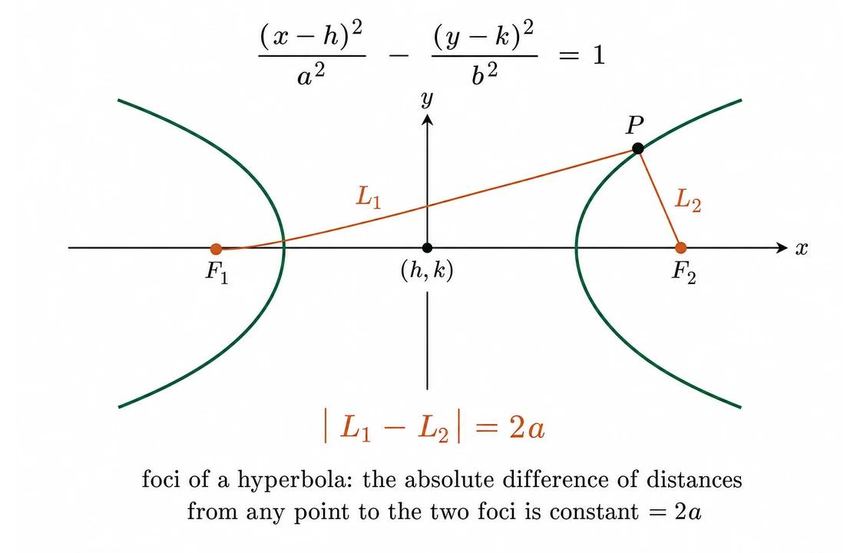
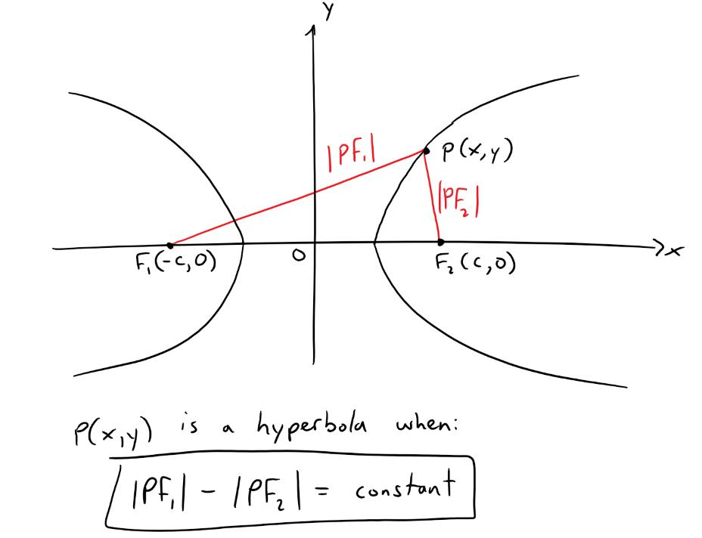

Simple Definition
# Source: AI Source: Provided by: [Data Path: Persons Table -> ID Column: 1, Name_En Column: Motasem Essam] -> From: [ChatGPT] on [7/25/2026]
A hyperbola is the set of all points whose difference in distances from two fixed points is constant.
For every point $P$on the hyperbola:
$$\boxed{∣PF_{1}-PF_{2}∣=2a}$$
The foci remain fixed while $P$moves along the hyperbola.

Fundamental Concept
# Source: AI Source: Provided by: [Data Path: Persons Table -> ID Column: 1, Name_En Column: Motasem Essam] -> From: [ChatGPT] on [7/25/2026]
A hyperbola is determined by:
- Two fixed points $F_{1}$and $F_{2}$, called the foci.
- A fixed positive constant $2a$, called the constant difference.
The fundamental locus condition is:
$$\boxed{∣PF_{1}-PF_{2}∣=2a}$$
Conceptually:
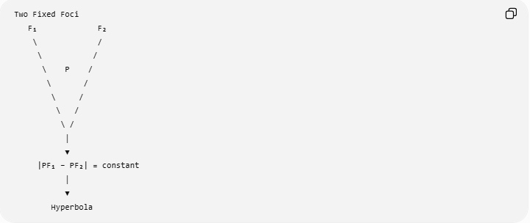
Two Fixed Foci
F₁ F₂
\ /
\ /
\ P /
\ /
\ /
\ /
\ /
│
▼
|PF₁ − PF₂| = constant
│
▼
Hyperbola

The Two Foci
# Source: AI Source: Provided by: [Data Path: Persons Table -> ID Column: 1, Name_En Column: Motasem Essam] -> From: [ChatGPT] on [7/25/2026]
The fixed points are called the foci of the hyperbola.
They are denoted:
$$\boxed{F_{1}, F_{2}}.$$
The foci lie on the hyperbola's transverse axis.
If $O$is the center, then:
$$\boxed{OF_{1}=OF_{2}=c}.$$
Therefore:
$$\boxed{F_{1}F_{2}=2c}.$$

Constant Difference of Distances
# Source: AI Source: Provided by: [Data Path: Persons Table -> ID Column: 1, Name_En Column: Motasem Essam] -> From: [ChatGPT] on [7/25/2026]
For every point $P$on a hyperbola:
$$\boxed{∣PF_{1}-PF_{2}∣=2a}.$$
For example, suppose:
$$PF_{1}=15$$
and:
$$PF_{2}=9.$$
Then:
$$∣15-9∣=6.$$
Therefore:
$$\boxed{2a=6}$$
and:
$$\boxed{a=3}.$$
Any other point on the same hyperbola must also have a distance difference of $6$.

Why the Absolute Value Is Important
# Source: AI Source: Provided by: [Data Path: Persons Table -> ID Column: 1, Name_En Column: Motasem Essam] -> From: [ChatGPT] on [7/25/2026]
The two branches of a hyperbola lie on opposite sides of the center.
On one branch, typically:
$$PF_{1}>PF_{2}.$$
On the other branch:
$$PF_{2}>PF_{1}.$$
Therefore, the ordinary difference changes sign from one branch to the other.
Using the absolute value gives one condition for both branches:
$$\boxed{∣PF_{1}-PF_{2}∣=2a}.$$
Equivalently, the two branches can be described by:
$$PF_{1}-PF_{2}=2a$$
or:
$$PF_{2}-PF_{1}=2a.$$

Example 1 — Basic Locus
# Source: AI Source: Provided by: [Data Path: Persons Table -> ID Column: 1, Name_En Column: Motasem Essam] -> From: [ChatGPT] on [7/25/2026]
Suppose two fixed points $F_{1}$and $F_{2}$are given, and a moving point $P$must satisfy:
$$∣PF_{1}-PF_{2}∣=10.$$
Then the locus of $P$is a hyperbola.
Since:
$$2a=10,$$
we obtain:
$$\boxed{a=5}.$$
Thus every point on the hyperbola has a distance difference of $10$from the two foci.

Geometric Construction
# Source: AI Source: Provided by: [Data Path: Persons Table -> ID Column: 1, Name_En Column: Motasem Essam] -> From: [ChatGPT] on [7/25/2026]
A hyperbola can be understood as a distance-difference locus.
Given two fixed foci $F_{1},F_{2}$:
- Fix $F_{1}$and $F_{2}$.
- Choose a point $P$such that the difference between $PF_{1}$and $PF_{2}$equals the fixed constant $2a$.
- Move $P$while maintaining:
$$∣PF_{1}-PF_{2}∣=2a.$$
- The resulting points trace the two branches of a hyperbola.
A classical construction can use intersecting circles with carefully chosen radii whose difference is fixed.
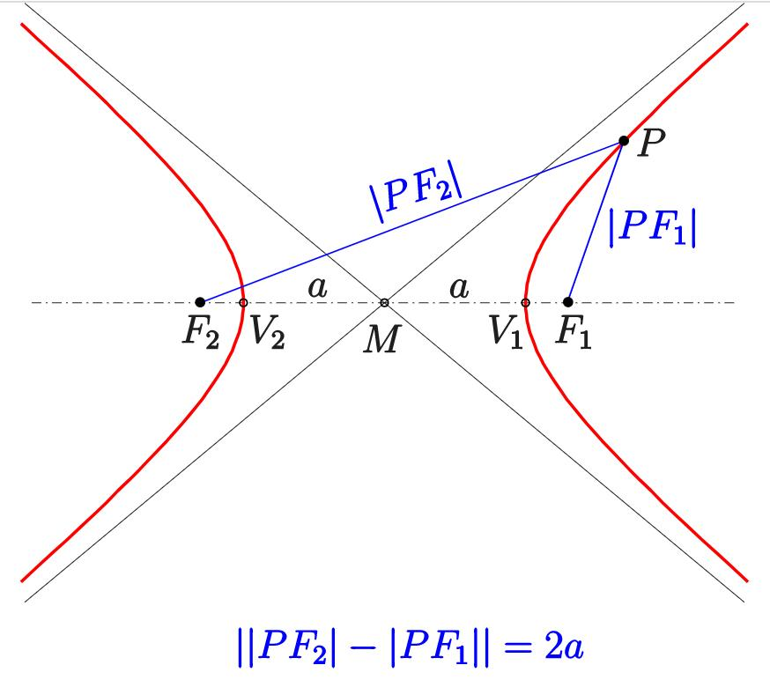
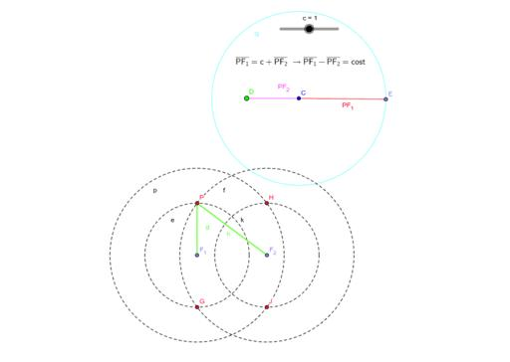
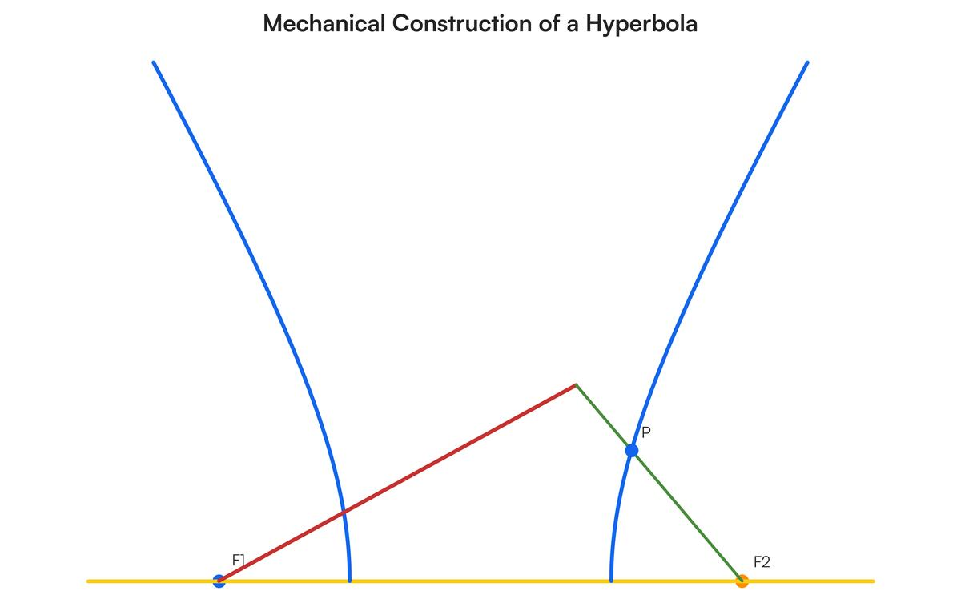
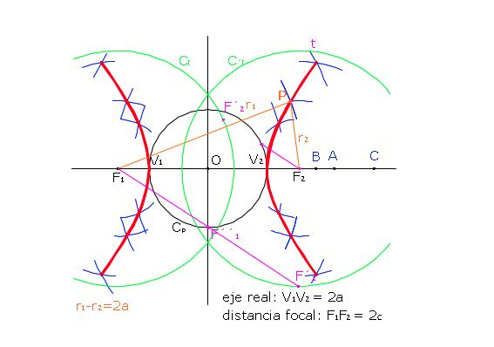
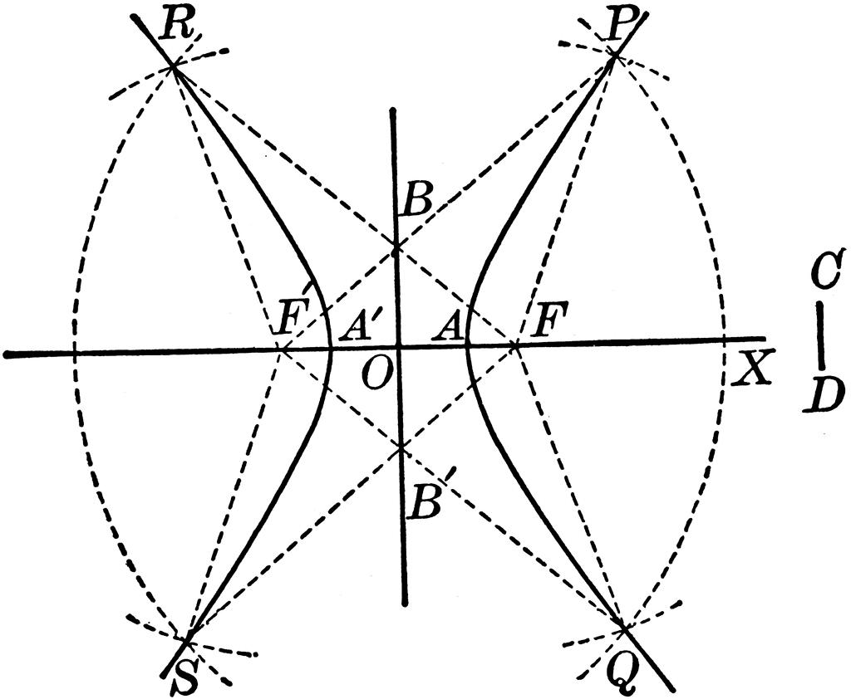

Center of a Hyperbola
# Source: AI Source: Provided by: [Data Path: Persons Table -> ID Column: 1, Name_En Column: Motasem Essam] -> From: [ChatGPT] on [7/25/2026]
The center $O$is the midpoint of the segment joining the two foci:
$$\boxed{OF_{1}=OF_{2}=c}.$$
Therefore:
$$\boxed{F_{1}F_{2}=2c}.$$
The center lies halfway between the two branches.
Unlike the ellipse, the center of a hyperbola does not lie on the hyperbola itself.

Transverse Axis
# Source: AI Source: Provided by: [Data Path: Persons Table -> ID Column: 1, Name_En Column: Motasem Essam] -> From: [ChatGPT] on [7/25/2026]
The transverse axis is the line passing through:
- the two foci
- the center
- the vertices.
Its length between the two vertices is:
$$\boxed{2a}.$$
The vertices are:
$$\boxed{V_{1},V_{2}}.$$

Vertices
# Source: AI Source: Provided by: [Data Path: Persons Table -> ID Column: 1, Name_En Column: Motasem Essam] -> From: [ChatGPT] on [7/25/2026]
The vertices are the points where the two branches come closest to the center.
For a horizontal hyperbola centered at the origin:
$$V_{1}=\left(- , a0\right), V_{2}=\left(a , 0\right).$$
The distance between the vertices is:
$$\boxed{2a}.$$
The locus condition at a vertex is particularly important.
For $V_{2}=\left(a , 0\right)$:
$$V_{2}F_{1}=c+a$$
and:
$$V_{2}F_{2}=c-a.$$
Therefore:
$$∣\left(c+a\right)-\left(c-a\right)∣=2a.$$
So the vertex satisfies the defining locus condition.

Fundamental Relationship
# Source: AI Source: Provided by: [Data Path: Persons Table -> ID Column: 1, Name_En Column: Motasem Essam] -> From: [ChatGPT] on [7/25/2026]
For a hyperbola:
$$\boxed{c^{2}=a^{2}+b^{2}}.$$
Therefore:
$$\boxed{b^{2}=c^{2}-a^{2}}.$$
Here:
- $a$= semi-transverse axis
- $b$= semi-conjugate axis
- $c$= center-to-focus distance
Since:
$$c^{2}=a^{2}+b^{2},$$
we have:
$$\boxed{c>a}.$$

Standard Equation — Horizontal Hyperbola
# Source: AI Source: Provided by: [Data Path: Persons Table -> ID Column: 1, Name_En Column: Motasem Essam] -> From: [ChatGPT] on [7/25/2026]
For a hyperbola centered at the origin opening left and right:
$$\boxed{\frac{x^{2}}{a^{2}}-\frac{y^{2}}{b^{2}}=1}$$
The foci are:
$$\boxed{F_{1}=\left(- , c0\right), F_{2}=\left(c , 0\right)}$$
where:
$$\boxed{c^{2}=a^{2}+b^{2}}.$$
The vertices are:
$$\boxed{\left(- , a0\right), \left(a , 0\right)}.$$

Standard Equation — Vertical Hyperbola
# Source: AI Source: Provided by: [Data Path: Persons Table -> ID Column: 1, Name_En Column: Motasem Essam] -> From: [ChatGPT] on [7/25/2026]
For a hyperbola opening upward and downward:
$$\boxed{\frac{y^{2}}{a^{2}}-\frac{x^{2}}{b^{2}}=1}$$
The foci are:
$$\boxed{F_{1}=\left(0 , -c\right), F_{2}=\left(0 , c\right)}$$
with:
$$\boxed{c^{2}=a^{2}+b^{2}}.$$
The vertices are:
$$\boxed{\left(0 , -a\right), \left(0 , a\right)}.$$
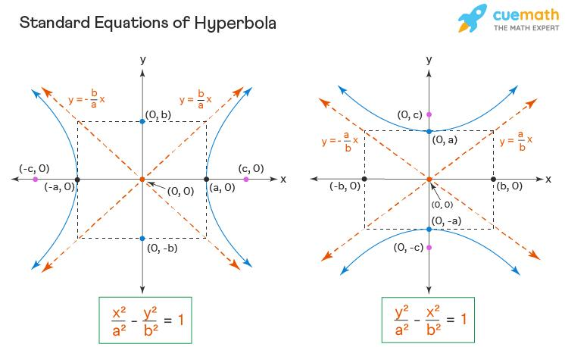
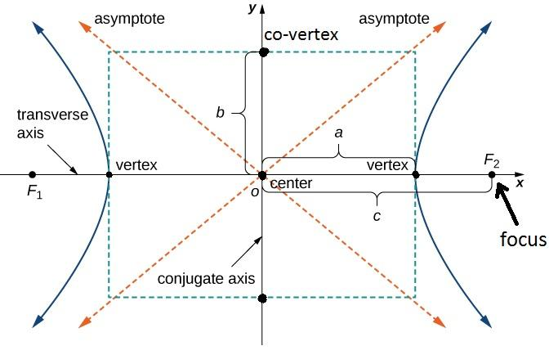
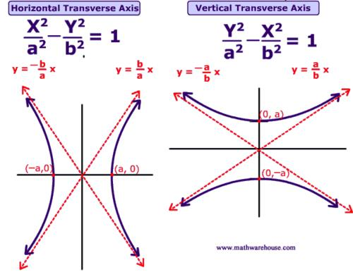
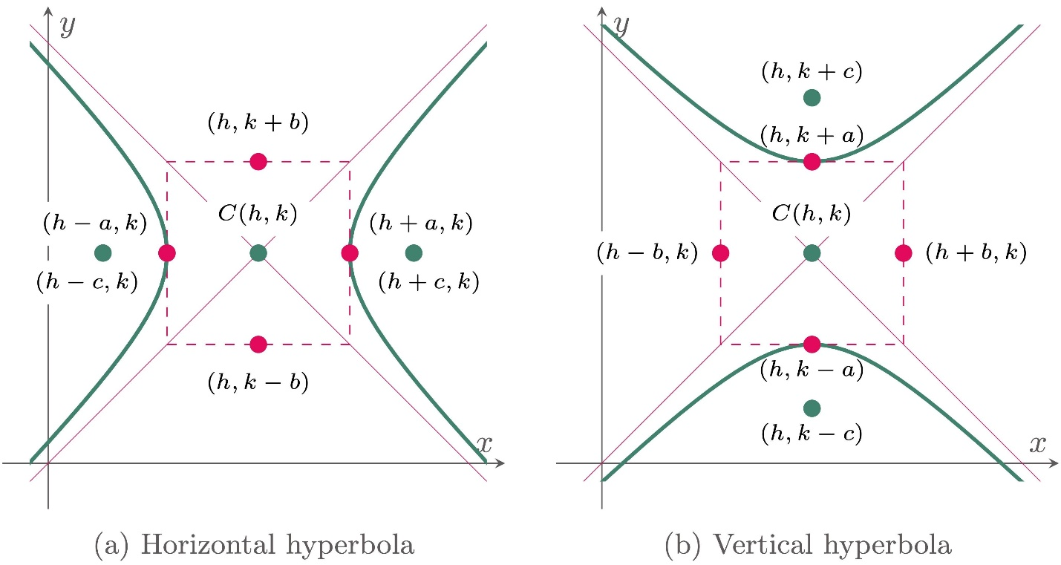
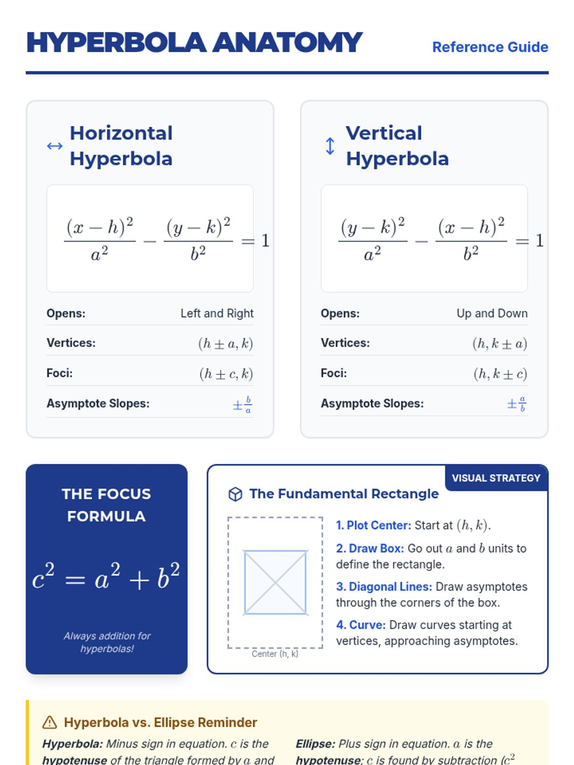

Deriving the Standard Equation from the Locus
# Source: AI Source: Provided by: [Data Path: Persons Table -> ID Column: 1, Name_En Column: Motasem Essam] -> From: [ChatGPT] on [7/25/2026]
Take the two foci:
$$F_{1}=\left(- , c0\right), F_{2}=\left(c , 0\right).$$
Let:
$$P=\left(x , y\right).$$
Then:
$$PF_{1}=\sqrt{{\left(x+c\right)}^{2}+y^{2}}$$
and:
$$PF_{2}=\sqrt{{\left(x-c\right)}^{2}+y^{2}}.$$
The hyperbola condition is:
$$∣\sqrt{{\left(x+c\right)}^{2}+y^{2}}-\sqrt{{\left(x-c\right)}^{2}+y^{2}}∣=2a.$$
Considering one branch, for example:
$$\sqrt{{\left(x+c\right)}^{2}+y^{2}}-\sqrt{{\left(x-c\right)}^{2}+y^{2}}=2a.$$
After algebraic simplification, the equation becomes:
$$\boxed{\frac{x^{2}}{a^{2}}-\frac{y^{2}}{b^{2}}=1}$$
where:
$$\boxed{c^{2}=a^{2}+b^{2}}.$$
Thus, the standard coordinate equation is a direct algebraic expression of the distance-difference locus.

Example 2 — Finding the Foci
# Source: AI Source: Provided by: [Data Path: Persons Table -> ID Column: 1, Name_En Column: Motasem Essam] -> From: [ChatGPT] on [7/25/2026]
Consider:
$$\boxed{\frac{x^{2}}{16}-\frac{y^{2}}{9}=1}.$$
Therefore:
$$a^{2}=16, b^{2}=9.$$
So:
$$a=4, b=3.$$
Using:
$$c^{2}=a^{2}+b^{2},$$
we obtain:
$$c^{2}=16+9=25.$$
Therefore:
$$c=5.$$
The foci are:
$$\boxed{F_{1}=\left(- , 50\right), F_{2}=\left(5 , 0\right)}.$$
The vertices are:
$$\boxed{\left(- , 40\right), \left(4 , 0\right)}.$$
For every point $P$on the hyperbola:
$$\boxed{∣PF_{1}-PF_{2}∣=8}.$$

Example 3 — Checking a Point
# Source: AI Source: Provided by: [Data Path: Persons Table -> ID Column: 1, Name_En Column: Motasem Essam] -> From: [ChatGPT] on [7/25/2026]
For:
$$\frac{x^{2}}{16}-\frac{y^{2}}{9}=1,$$
consider:
$$P=\left(5 , 3\right).$$
The foci are:
$$F_{1}=\left(- , 50\right), F_{2}=\left(5 , 0\right).$$
Calculate:
$$PF_{1}=\sqrt{{\left(5+5\right)}^{2}+3^{2}} \\ =\sqrt{100+9} \\ =\sqrt{109}.$$
And:
$$PF_{2}=\sqrt{{\left(5-5\right)}^{2}+3^{2}}=3.$$
Therefore:
$$∣PF_{1}-PF_{2}∣=\sqrt{109}-3.$$
This is not equal to $8$, so:
$$\boxed{P\text{ is not on the hyperbola}}.$$

Example 4 — A Point That Is on the Hyperbola
# Source: AI Source: Provided by: [Data Path: Persons Table -> ID Column: 1, Name_En Column: Motasem Essam] -> From: [ChatGPT] on [7/25/2026]
For the same hyperbola, consider the vertex:
$$P=\left(4 , 0\right).$$
The foci are:
$$F_{1}=\left(- , 50\right), F_{2}=\left(5 , 0\right).$$
Then:
$$PF_{1}=9$$
and:
$$PF_{2}=1.$$
Therefore:
$$∣PF_{1}-PF_{2}∣=∣9-1∣=8.$$
Since:
$$2a=8,$$
we have:
$$\boxed{P\text{ lies on the hyperbola}}.$$

Inside and Outside the Hyperbola
# Source: AI Source: Provided by: [Data Path: Persons Table -> ID Column: 1, Name_En Column: Motasem Essam] -> From: [ChatGPT] on [7/25/2026]
The ellipse has a simple inside/outside distinction because it is a closed curve.
A hyperbola is different because it consists of two open branches and divides the plane into multiple regions.
The quantity
$$∣PF_{1}-PF_{2}∣$$
can still be compared with $2a$, but the interpretation of "inside" and "outside" is not as simple as for a circle or ellipse.
The boundary itself is:
$$\boxed{∣PF_{1}-PF_{2}∣=2a}.$$
Points satisfying:
$$∣PF_{1}-PF_{2}∣>2a$$
and:
$$∣PF_{1}-PF_{2}∣<2a$$
lie in different regions relative to the hyperbola.
Importantly, the set
$$∣PF_{1}-PF_{2}∣<2a$$
is a connected central region between the two branches, while the regions corresponding to
$$∣PF_{1}-PF_{2}∣>2a$$
are associated with the outer sides of the two branches.

Asymptotes
# Source: AI Source: Provided by: [Data Path: Persons Table -> ID Column: 1, Name_En Column: Motasem Essam] -> From: [ChatGPT] on [7/25/2026]
A hyperbola has two asymptotes.
For:
$$\frac{x^{2}}{a^{2}}-\frac{y^{2}}{b^{2}}=1,$$
the asymptotes are:
$$\boxed{y=\frac{b}{a}x}$$
and:
$$\boxed{y=-\frac{b}{a}x}.$$
The branches approach these lines but do not intersect them in the ordinary finite plane.
The asymptotes help describe the overall shape of the hyperbola.

Eccentricity
# Source: AI Source: Provided by: [Data Path: Persons Table -> ID Column: 1, Name_En Column: Motasem Essam] -> From: [ChatGPT] on [7/25/2026]
The eccentricity of a hyperbola is:
$$\boxed{e=\frac{c}{a}}.$$
Because:
$$c>a,$$
we have:
$$\boxed{e>1}.$$
This distinguishes the hyperbola from the ellipse and parabola.
For comparison:
$$\boxed{\begin{aligned}\text{Circle: }&e=0 \\ \text{Ellipse: }&0<e<1 \\ \text{Parabola: }&e=1 \\ \text{Hyperbola: }&e>1\end{aligned}}$$

Hyperbola as a Conic Locus
# Source: AI Source: Provided by: [Data Path: Persons Table -> ID Column: 1, Name_En Column: Motasem Essam] -> From: [ChatGPT] on [7/25/2026]
The hyperbola belongs to the family of conic sections.
Its distance-based locus definition is:
$$\boxed{∣PF_{1}-PF_{2}∣=\text{constant}}.$$
The four basic conic loci can be organized as:
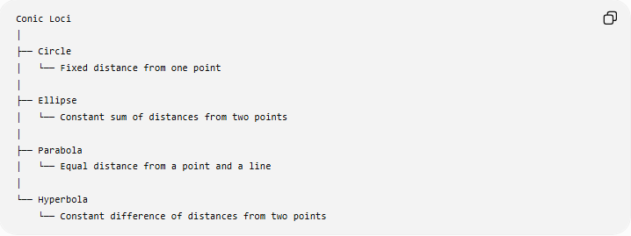
Conic Loci
│
├── Circle
│ └── Fixed distance from one point
│
├── Ellipse
│ └── Constant sum of distances from two points
│
├── Parabola
│ └── Equal distance from a point and a line
│
└── Hyperbola
└── Constant difference of distances from two points

Hyperbola vs Ellipse
# Source: AI Source: Provided by: [Data Path: Persons Table -> ID Column: 1, Name_En Column: Motasem Essam] -> From: [ChatGPT] on [7/25/2026]
The distinction between an ellipse and a hyperbola is especially important.
Ellipse
$$\boxed{PF_{1}+PF_{2}=2a}$$
The sum is constant.
Hyperbola
$$\boxed{∣PF_{1}-PF_{2}∣=2a}$$
The absolute difference is constant.
Therefore:
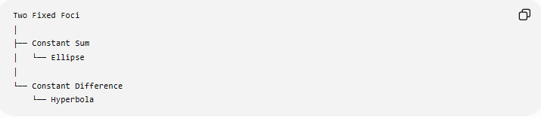
Two Fixed Foci
│
├── Constant Sum
│ └── Ellipse
│
└── Constant Difference
└── Hyperbola
The ellipse is closed, while the hyperbola has two separate branches.

Hyperbola vs Parabola
# Source: AI Source: Provided by: [Data Path: Persons Table -> ID Column: 1, Name_En Column: Motasem Essam] -> From: [ChatGPT] on [7/25/2026]
A parabola uses:
$$\boxed{PF=d\left(P , l\right)}$$
where $F$is a fixed point and $l$is a fixed line.
A hyperbola uses:
$$\boxed{∣PF_{1}-PF_{2}∣=2a}$$
where $F_{1},F_{2}$are two fixed points.
Therefore:
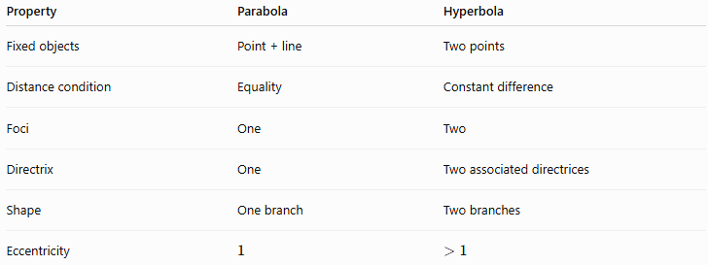
Property | Parabola | Hyperbola
Fixed objects | Point + line | Two points
Distance condition | Equality | Constant difference
Foci | One | Two
Directrix | One | Two associated directrices
Shape | One branch | Two branches
Eccentricity | $$1$$ | $$>1$$

Hyperbola vs Circle
# Source: AI Source: Provided by: [Data Path: Persons Table -> ID Column: 1, Name_En Column: Motasem Essam] -> From: [ChatGPT] on [7/25/2026]
A circle can be viewed as a special ellipse:
$$e=0.$$
A hyperbola has:
$$e>1.$$
Their basic locus definitions are very different:
$$\boxed{\text{Circle: }OP=r}$$
versus:
$$\boxed{\text{Hyperbola: }∣PF_{1}-PF_{2}∣=2a}.$$

Directrices of a Hyperbola
# Source: AI Source: Provided by: [Data Path: Persons Table -> ID Column: 1, Name_En Column: Motasem Essam] -> From: [ChatGPT] on [7/25/2026]
A hyperbola also has two directrices associated with its focus-directrix characterization.
For a horizontal hyperbola centered at the origin:
$$\boxed{x=\frac{a}{e}}$$
and:
$$\boxed{x=-\frac{a}{e}}.$$
Since:
$$e=\frac{c}{a},$$
we have:
$$\boxed{\frac{a}{e}=\frac{a^{2}}{c}}.$$
The hyperbola can also be characterized using the focus-directrix ratio:
$$\boxed{\frac{\text{distance to focus}}{\text{distance to corresponding directrix}}=e}$$
with:
$$\boxed{e>1}.$$
This is a second important locus characterization of the hyperbola.

Two Locus Definitions of a Hyperbola
# Source: AI Source: Provided by: [Data Path: Persons Table -> ID Column: 1, Name_En Column: Motasem Essam] -> From: [ChatGPT] on [7/25/2026]
The hyperbola therefore has two important distance-based descriptions.
Focus-Focus Definition
$$\boxed{∣PF_{1}-PF_{2}∣=2a}$$
Focus-Directrix Definition
$$\boxed{\frac{PF}{d\left(P , l\right)}=e}$$
where:
$$\boxed{e>1}.$$
The first definition is usually the most direct when introducing the hyperbola as a locus.

Classification Summary
# Source: AI Source: Provided by: [Data Path: Persons Table -> ID Column: 1, Name_En Column: Motasem Essam] -> From: [ChatGPT] on [7/25/2026]
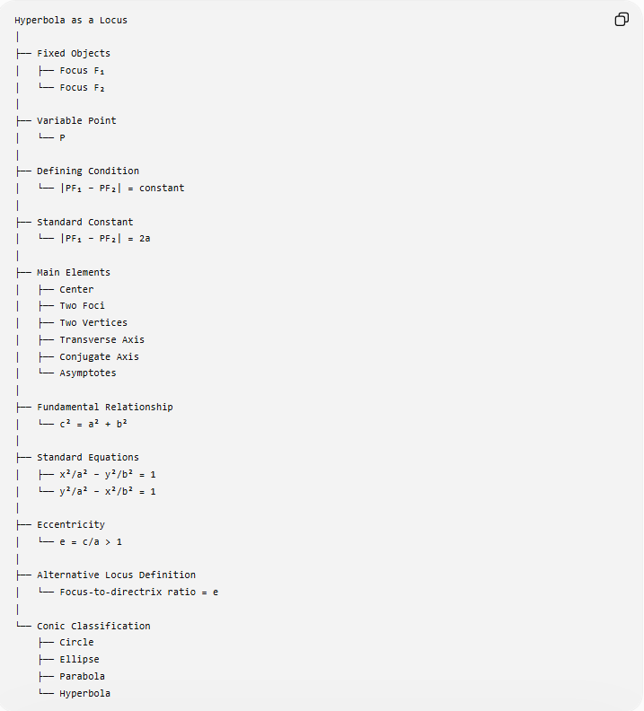
Hyperbola as a Locus
│
├── Fixed Objects
│ ├── Focus F₁
│ └── Focus F₂
│
├── Variable Point
│ └── P
│
├── Defining Condition
│ └── |PF₁ − PF₂| = constant
│
├── Standard Constant
│ └── |PF₁ − PF₂| = 2a
│
├── Main Elements
│ ├── Center
│ ├── Two Foci
│ ├── Two Vertices
│ ├── Transverse Axis
│ ├── Conjugate Axis
│ └── Asymptotes
│
├── Fundamental Relationship
│ └── c² = a² + b²
│
├── Standard Equations
│ ├── x²/a² − y²/b² = 1
│ └── y²/a² − x²/b² = 1
│
├── Eccentricity
│ └── e = c/a > 1
│
├── Alternative Locus Definition
│ └── Focus-to-directrix ratio = e
│
└── Conic Classification
├── Circle
├── Ellipse
├── Parabola
└── Hyperbola

Key Formulas
# Source: AI Source: Provided by: [Data Path: Persons Table -> ID Column: 1, Name_En Column: Motasem Essam] -> From: [ChatGPT] on [7/25/2026]
Locus Definition
$$\boxed{∣PF_{1}-PF_{2}∣=2a}$$
Distance Between Foci
$$\boxed{F_{1}F_{2}=2c}$$
Fundamental Relationship
$$\boxed{c^{2}=a^{2}+b^{2}}$$
Horizontal Hyperbola
$$\boxed{\frac{x^{2}}{a^{2}}-\frac{y^{2}}{b^{2}}=1}$$
Vertical Hyperbola
$$\boxed{\frac{y^{2}}{a^{2}}-\frac{x^{2}}{b^{2}}=1}$$
Eccentricity
$$\boxed{e=\frac{c}{a}>1}$$
Horizontal Asymptotes
$$\boxed{y=±\frac{b}{a}x}$$
Directrix Distance Form
$$\boxed{\frac{PF}{d\left(P , l\right)}=e}$$

Key Points
# Source: AI Source: Provided by: [Data Path: Persons Table -> ID Column: 1, Name_En Column: Motasem Essam] -> From: [ChatGPT] on [7/25/2026]
- A hyperbola is a locus.
- It is defined using two fixed points, the foci.
- The fundamental condition is:
$$\boxed{∣PF_{1}-PF_{2}∣=2a}.$$
- The absolute difference is constant.
- A hyperbola has two branches.
- The foci lie on the transverse axis.
- The center is the midpoint of the two foci.
- The vertices are separated by $2a$.
- The foci are separated by $2c$.
- The fundamental relationship is:
$$\boxed{c^{2}=a^{2}+b^{2}}.$$
- Its eccentricity satisfies:
$$\boxed{e>1}.$$
- It has two asymptotes.
- It has a second focus-directrix characterization.
- Unlike an ellipse, it uses a difference rather than a sum of distances.

Conclusion
# Source: AI Source: Provided by: [Data Path: Persons Table -> ID Column: 1, Name_En Column: Motasem Essam] -> From: [ChatGPT] on [7/25/2026]
The hyperbola as a locus is the set of all points $P$for which the absolute difference between the distances to two fixed points $F_{1}$and $F_{2}$is constant:
$$\boxed{∣PF_{1}-PF_{2}∣=2a}.$$
The two fixed points are the foci, and $2a$is the constant difference and the length of the transverse axis.
The central principle is:
$$\boxed{\text{Constant Difference of Distances from Two Fixed Points}⟶\text{Hyperbola}}$$
This completes the basic distance-based definitions of the four fundamental conic loci:
$$\boxed{\begin{aligned}\text{Circle}&→\text{Fixed Distance} \\ \text{Ellipse}&→\text{Constant Sum} \\ \text{Parabola}&→\text{Point-Line Equidistance} \\ \text{Hyperbola}&→\text{Constant Difference}\end{aligned}}$$

